Grade Setup for Lake View
9 – 12 Year Long Courses

- Click on the Grade Set-Up Tab – Y1 should be on Term Weights with the following percents: S1 = 40%, S2 = 40%, and E1 = 20%
- *(Important – if the Y1 information does not show up on the split screen you will need to click File and Refresh Class Info. or double click on the F1 folder)

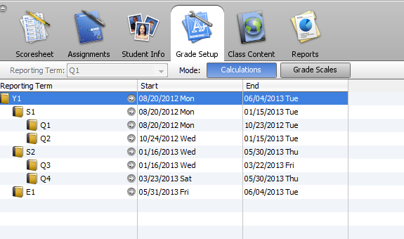

- Expand S1 and S2 where Q1 & Q2 show – do not change any percents.

- Enter the weights as shown below: S1=40, S2=40, & E1=20. This must be done each semester.

2. Select S1 & S2; make
sure Total points are selected for both. Click Save.

Continue gradebook setup for Quarters on next page.

3. Select Q1.

4. Select Category Weights.
**There are four (4) categories by default. You can add your own or rename these to meet your needs. The following requirements must be met:
Example
- Highest Category Weight can be no more than 30%.
- Should have at least 4 Categories.
- Should have at least 4 grades in each category per nine weeks.

- Click the +Add Category to add these as shown in the example and to put in the correct weights you are using. Category Weights should be consistent with each subject and grade level for Q1, Q2, Q3, & Q4.

- You will need to do this for each class and each quarter. **New Feature: See handout for Copying Q1 Setup and Final Grade Setup.

The following will need to be done at the end of the grading period (Y1 – Year Course). The E1 bucket will be on Total Points:

- Click the Assignment tab and Select E1 by the Reporting Term.

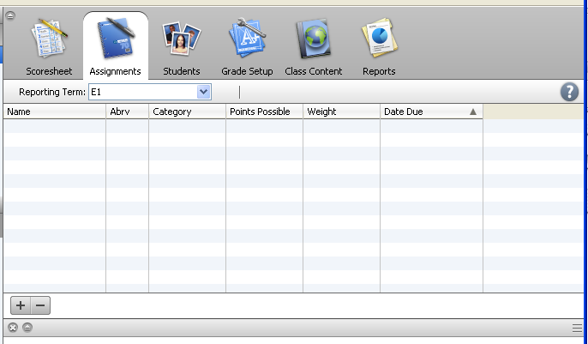

- Click the plus sign (+) at the bottom to create your assignment name for
the End of Course Test/Exam and add your grades.

